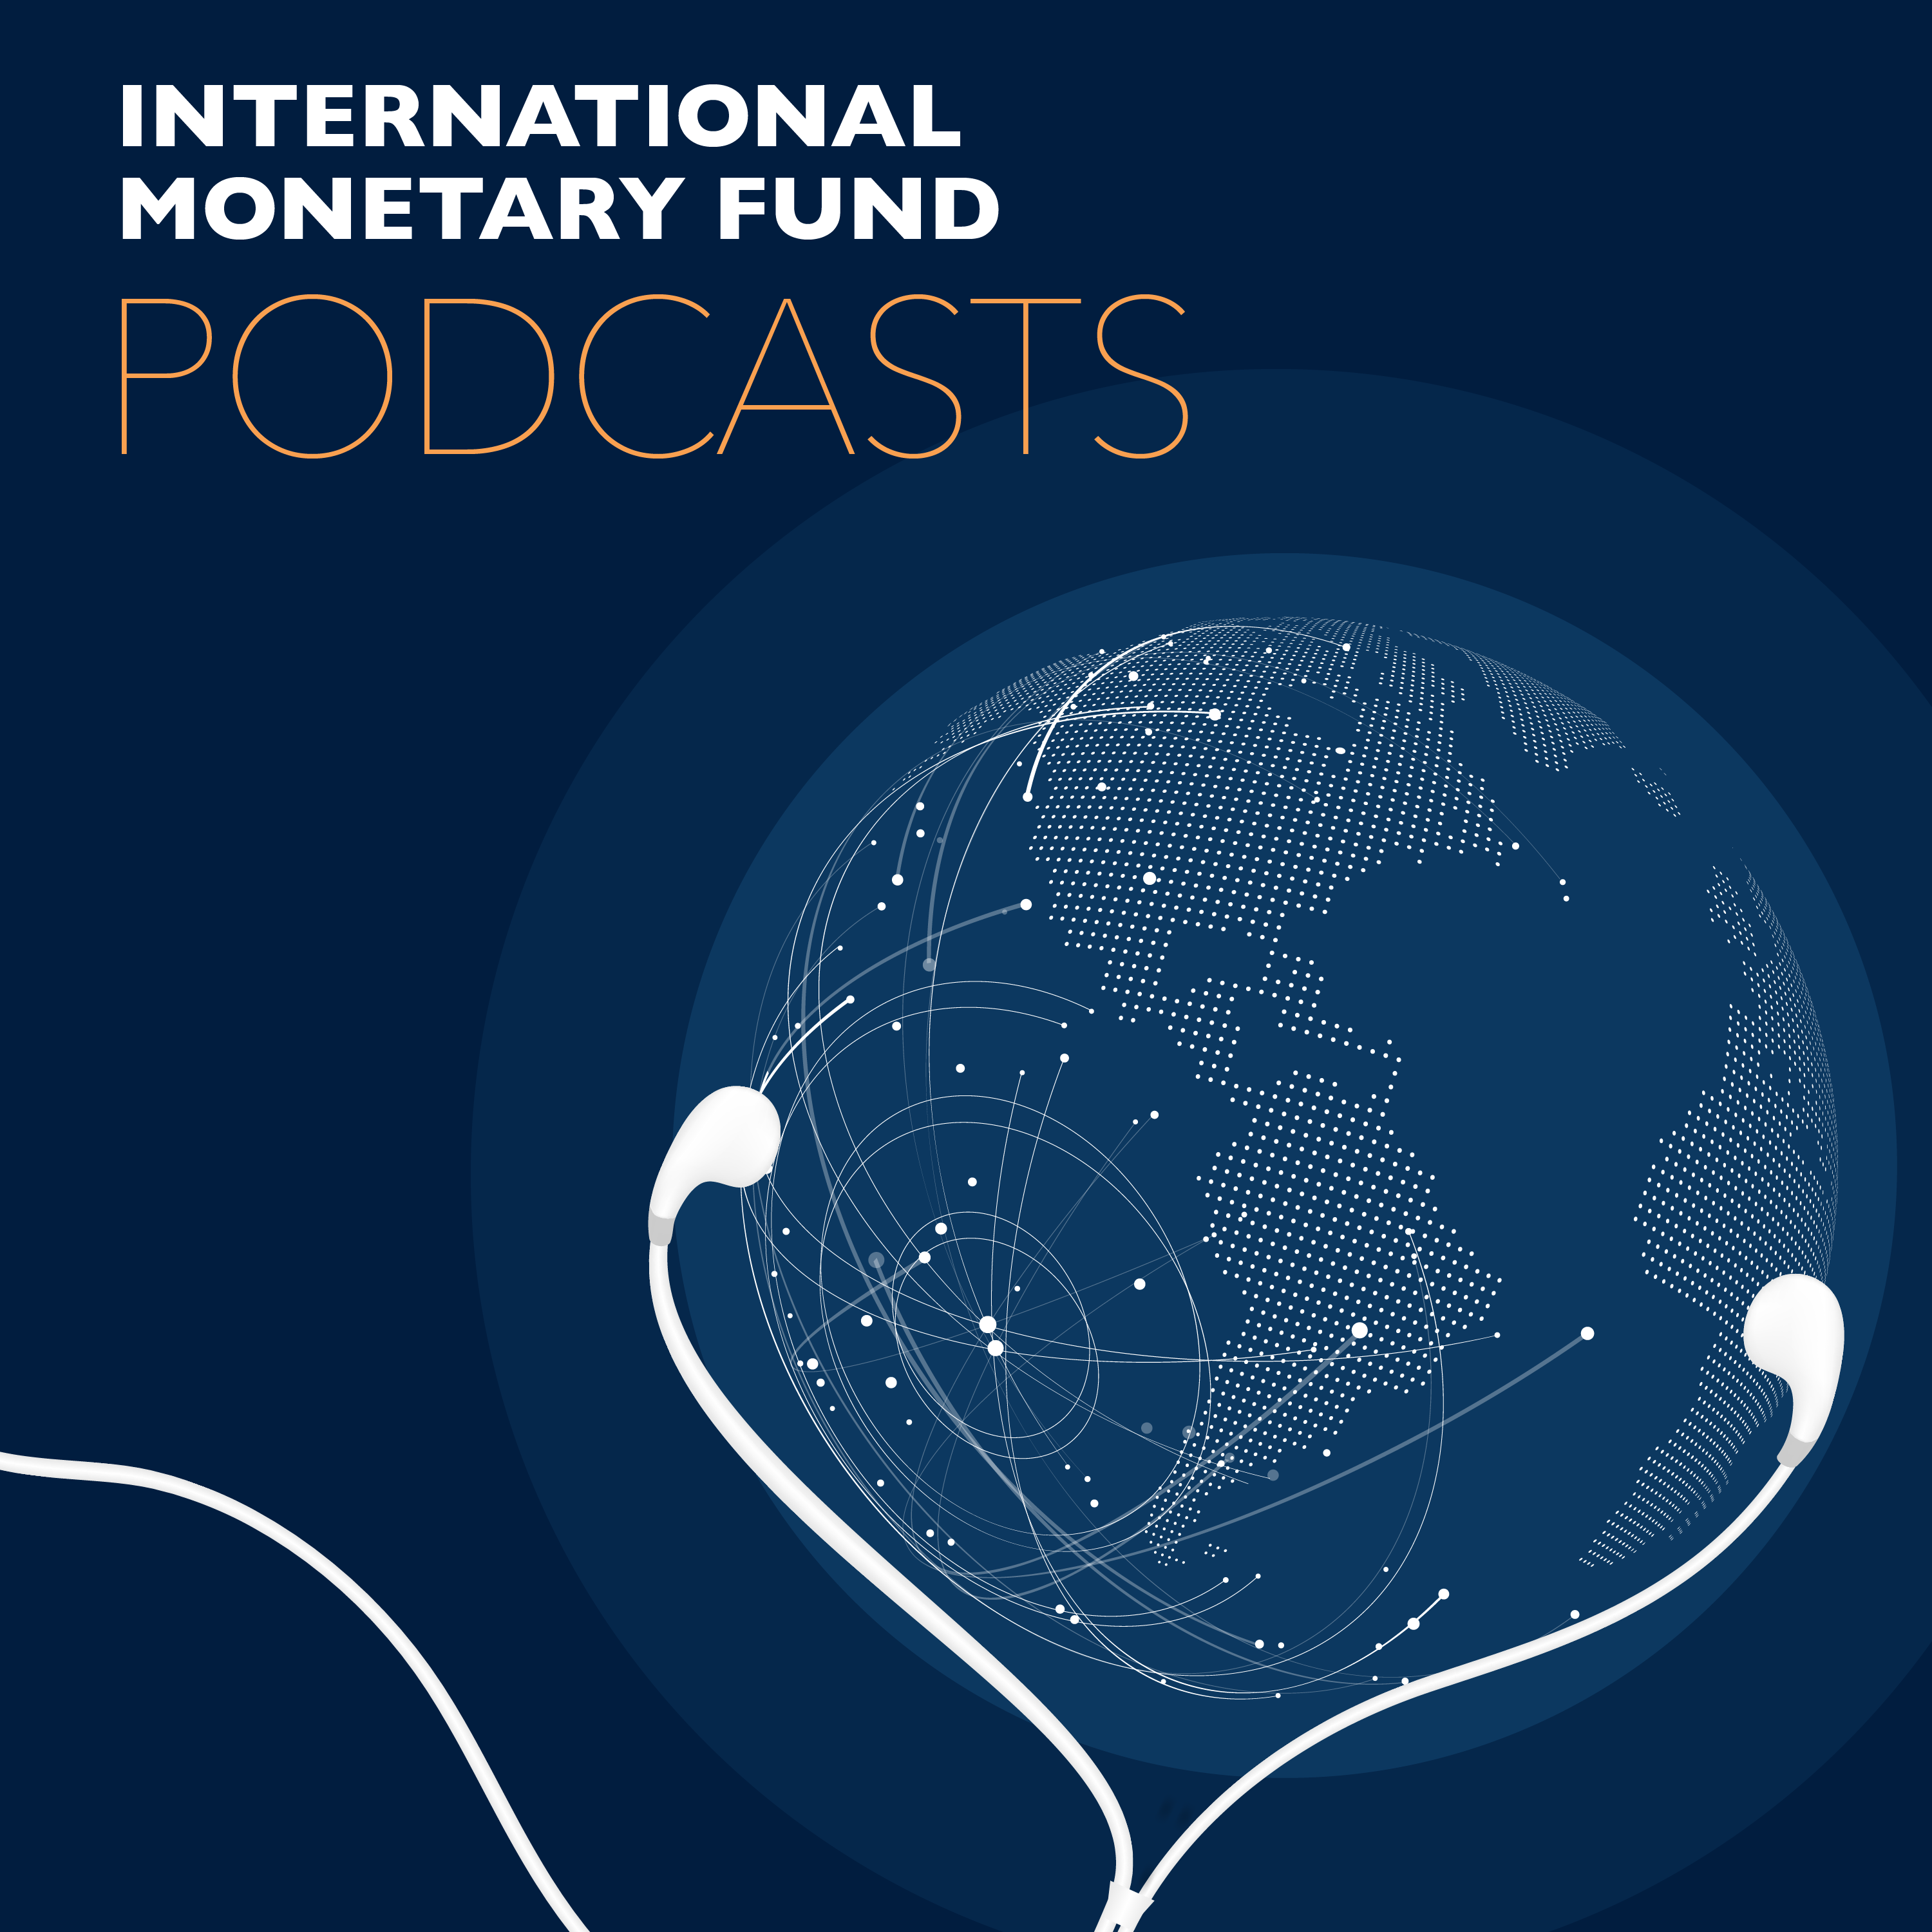
Transcript of IMF podcast:
Abebe Aemro Selassie: What Covid-19 Means for sub-Saharan Africa
Bruce Edwards:
A note to our listeners before we get started. The coronavirus pandemic has changed the way people work across the globe, and IMF Podcasts are no exception. So please bear with us during this time when interviewing guests in our regular studios is not possible. And while we try to get the best audio quality possible under these unfortunate circumstances. On with the show.
Abebe Aemro Selassie:
I fear the impact of this pandemic is going to be really quite devastating on the region.
Bruce Edwards:
In this program, IMF Africa Department Head, Abebe Aemro Selassie, on what COVID-19 means for Sub-Saharan Africa.
Abebe Aemro Selassie:
I think we're all in this together, and it's imperative to support that African people. African countries need to be able to combat this virus both in the health front, but also supporting the livelihoods that are going to be devastated as a result of this pandemic, is going to be really important.
Bruce Edwards:
Welcome to this podcast produced by the International Monetary Fund. I'm Bruce Edwards. Countries in Sub-Saharan Africa are taking sweeping measures to halt the advance of COVID-19, imposing limits on public gatherings and the like. But for the region's most vulnerable, social distancing is not realistic. Abebe Aemro Selassie says anything that will help contain the spread of the virus, like closing borders to people, will help minimize added strain on already fragile health systems. Selassie is the director of the IMF's Africa Department. So health systems, even in the most advanced economies are struggling to keep up with this pandemic. Are health systems in Sub-Saharan Africa up to the challenge, if the disease spreads into the region to the degree that it has in other parts of the world?
Abebe Aemro Selassie:
The short answer is very unlikely, very unlikely. We've seen basically how dangerous this virus is and how it has overwhelmed completely the health systems in advanced countries, which are way better staffed than those in most sub-Saharan African countries, much better equipped. So even the initial conditions that we have in the region are fairly weak health systems. My sense would be that if we have the same degree of spread, the health systems will not be able to cope. Which is why I think the measures countries have been trying to take to basically limit the importation of coronavirus cases by shutting borders to passengers, not goods, I should add, a very important caveat. I think those have been very understandable and very important measures to try and limit the number of cases being imported. Second, also beginning the process of limiting gatherings, practice social distancing and the like, really are very important. But this also is very challenging for most countries in the region of course.
Abebe Aemro Selassie:
Unlike most advanced countries, or many EM's, emerging market countries, working from home is not going to be an option, but for a tiny fraction of the workforce. And in most sub-Saharan African countries, the vast majority of people work in the informal sector or in factories, or small and medium sized enterprises and the like. Either of the enterprises will not have the resources to sustain and keep people employed beyond a small number of days. Or, if you're working in informal type activities, you have to go out on a daily basis to make a living. So working from home is not really an option. It's really giving up on your livelihood. So in the end all measures governments can take to suppress and limit the spread of the disease is going to be very, very important.
Bruce Edwards:
So limited integration really helped sub-Saharan Africa from being swept up by the global financial crisis in 2008. How do you expect the region will fare through this global pandemic?
Abebe Aemro Selassie:
I worry that the impact on the region this time round could end up being really quite devastating. In 2008, '09 as you noted, the extent to which countries were integrated into the global economy was limited on the financial side. But I think an even more important reason why countries were able to withstand the pressure, was because they had a lot of fiscal space. So debt levels were fairly low. So when the global financial crisis hit, and that slowdown was transmitted into the region, companies were able to have fairly counter-cyclical policies, allow fiscal deficits to widen, to undertake the investment projects, to buttress some strength and support for economic activity. So the vast majority of countries in the region, the hit to growth was limited because of this. Financially also, at that time there was less reliance on global capital markets than is the case now.
Abebe Aemro Selassie:
So this time what we have is a situation where debt level is pronounced for the vast majority of countries. And also there's much greater reliance on the financial markets. A lot more borrowing through Euro bonds, syndicated loans and the like. So there are three channels in which the impact of this pandemic is going to be felt. First and foremost, there is the measures that governments are taking to limit the spread of the disease. Limiting airline flights. Limiting the number of gatherings, forcing the shutdown of some businesses and the like. Those are going to cause a really big drag on economic activity.
Abebe Aemro Selassie:
Second, the decline in economic activity in the rest of the world is going to be felt in the region also. What started as a health crisis, this health pandemic has morphed into a major global economic crisis with global GDP growth, to slump at the minimum to the levels that we saw during the global financial crisis this year. And this will have a drag in terms of demand for African exports in terms of investment decisions that non-residents would be undertaking in Africa, financing decisions. So this globally weaker environment will be a big drag. And the third channel is the sharp decline in commodity prices, and particularly of oil.
Bruce Edwards:
And the larger economies in the region took a big hit when oil prices fell in 2014. How will this recent plunge in oil prices play into the region's ability to recover from this health crisis?
Abebe Aemro Selassie:
So this would be mainly impactful for eight oil exporting countries in the region, Sub-Saharan Africa. I fear it's going to be really quite a drastic shock. Already most of these countries were in a very a weak footing as a result of the decline in oil prices in 2014, '15. The adjustment to that decline from oil prices 80, $100, to the 50, 60, as we've been seeing in recent last couple of years, was not complete in some cases. So it's on top of that severe shock a few years ago, that this decline in oil prices to below $50 is happening. So the impact will be quite severe on the fiscal accounts, on external accounts, and growth in many of the oil exporting countries.
Abebe Aemro Selassie:
In the oil importing countries, which comprise the vast majority of countries in the region. Of course this declared oil price shock will not be as harmful. In fact, it could even be beneficial, because they're oil importers, they will be facing lower oil bills. But of course the net effects for oil importing countries also is going to be negative, because they are going to be facing a massively slower economic activity as a result of those measures they're taking to suppress the disease. Shutting down their borders, which will stymie tourism, which will delay investment decisions that have to be made, financing arrangements that have to be facilitated. So all told, the exogenous shock that the region is going to be feeling, coupled with the domestic measures countries are undertaking, will have a very severe adverse impact on countries.
Bruce Edwards:
So what will it take to prevent the economies in Sub-Saharan Africa from faltering under this pressure of COVID-19?
Abebe Aemro Selassie:
I think first and foremost, of course this is a health crisis, and it is paramount that countries do what ever they can to limit the spread of the disease, invest whatever it takes to really combat the disease and can bring it under control. That has to be the priority. So fiscal monetary resources has to be put towards addressing this health emergency. I mean that's important in the very short term. To address the drag on economies that is going to come from slower activity as a result of measures being taken domestically, but also the external demand slow down. There we see scope for fiscal policy to be expansionary this year. The hope and expectation is that this is a one-off shock, rather than something that's going to impact other fiscal accounts or a big economy on a permanent basis.
Abebe Aemro Selassie:
So the right measure we feel is to try and have a counter-cyclical response to the crisis. Once the crisis ends, fiscal deficits can revert back to the medium term paths that are consistent with sustainability considerations. But for this year, for while the crisis is with us, it's important we feel for fiscal policy to help and defray some of this shock. This could include in those countries which has additional buffers, this could include measures to try and do targeted interventions to support firms, and people above all, that have been impacted by the economic slow down. So that's on the fiscal policy side. On the monetary policy side, where exchange rates are flexible, allowing that rates to move, to absorb some of the shock we feel will be important. Some monetary easing also, could be the response. Again, this depends very much on country circumstances, but monetary policy we feel also has a role to play in being accommodative overall. And also looking at to make sure that financial sector can be protected through regulatory considerations that central banks can take.
Abebe Aemro Selassie:
So this policy response should help. Of course the big constraint in many of our countries in the region, is to having an expansion, a supportive fiscal policy stance is the lack of financing. And I think this is where the international community can come to support. We at the IMF of course, are in very active discussions with a very large number of countries right now to provide very quick financing. So we're doing that. But I think there's a role also to be played by other international financial institutions, and countries development partners also, to try and avail as much grant-type financing, very concessional financing for countries. So the appropriate counter-cyclical policies can be pursued in countries in the midst of this crisis.
Bruce Edwards:
When you speak of these fiscal policies, even though they may be temporary, we're still likely talking massive amounts of money for these measures, in a region where the resources are scarce in the best of times. How confident are you that the donor community will step up to the plate and provide the financing that the region really needs?
Abebe Aemro Selassie:
You're right, too often limited financing is what stops countries from pursuing supportive policies when they're hit by shocks in the region. Which is why we're working incredibly hard with other international financial institutions to make sure that African countries should not have to go at it alone. There's no bigger priority for our institution than making sure that the necessary financing that countries need is provided. And the IMF is doing its utmost to make sure that we can have financing available as quickly as possible. And we're working on this, much the same really for institutions like the World Bank of course, African Development Bank. And we're partnering here and trying to collaborate as closely as we can with the WHO, African Union and others, to make sure that Africa doesn't have to go at it alone. I think international solidarity at this time is incredibly important.
Abebe Aemro Selassie:
I'm reminded of something that Gabriel García-Márquez wrote in his wonderful book, Love in the Time of Cholera, where he says, "Humanity like armies in the field, advances at the pace of the most vulnerable." And I think for the international community, just the importance of supporting Africa, I think really cannot be stressed enough. Absent the eradication of this virus around the world, the likelihood that it will re-emerge again in the advanced countries, or other countries that have pushed it out of their territory is very likely. So I think we're all in this together. I think it behooves everybody in the international financial community in making sure that the necessary financing to support those people whose livelihoods are going to be turned upside down as a result of the spread of the disease, and the measures to counter it that are being taken, is imperative for the wellbeing of the global economy also, in the medium to long run.
Bruce Edwards:
Thanks so much Abe for your insight into how the pandemic is affecting Sub-Saharan Africa, and I hope next time we talk it'll be about how the region is bouncing back.
Abebe Aemro Selassie:
I very much hope so too. Very much hope so. Thank you Bruce.
Bruce Edwards:
Abebe Aemro Selassie is the director of the IMF's African department. You can read his blog on the impact of COVID-19 on sub-Saharan Africa at blogs.imf.org. You can also find out more about how the IMF and its global partners are responding to the coronavirus pandemic at IMF.org. Look for other IMF podcasts wherever you get your podcasts. Subscribe if you like what you're hearing, and follow us on Twitter @IMF_Podcast. Thanks for listening.

