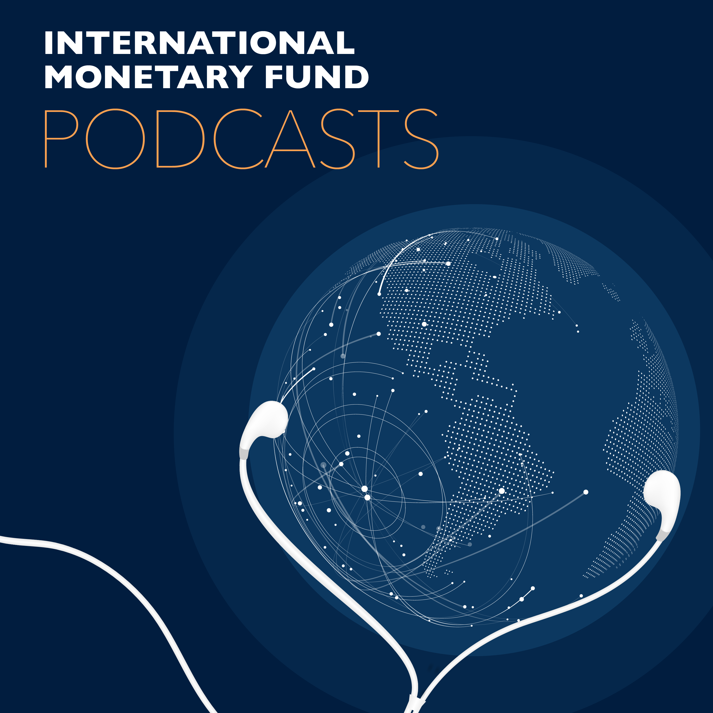
Transcript of IMF podcast:
Confronting the Crisis: Priorities for the Global Economy
By Kristalina Georgieva, IMF Managing Director
Introduction: A Crisis Like No Other
I want to begin by wishing my personal best to everyone—for you and your families’ health and safety during these difficult times.
Today we are confronted with a crisis like no other. What was normal just a few weeks ago—going to school, going to work, being with family and friends—is now a huge risk.
I have no doubt that we will overcome this challenge. Our doctors and nurses are fighting it around the clock, often risking their lives to save the lives of others. Our scientists will come up with solutions to break COVID-19’s grip. Between now and then, we must marshal the determination of all—individuals, governments, businesses, community leaders, international organizations—to act decisively and act together, to protect lives and livelihoods.
The actions we take now will determine the speed and strength of our recovery. That will be the focus of the IMF’s 189 member countries when we meet in our virtual Spring Meetings next week.
It is what I will concentrate on today.
Where We Stand: the Status of the Global Economy
First, let’s look at where we stand. We are still faced with extraordinary uncertainty about the depth and duration of this crisis.
It is already clear, however, that global growth will turn sharply negative in 2020, as you will see in our World Economic Outlook next week. In fact, we anticipate the worst economic fallout since the Great Depression.
Just three months ago, we expected positive per capita income growth in over 160 of our member countries in 2020. Today, that number has been turned on its head: we now project that over 170 countries will experience negative per capita income growth this year.
And just as the health crisis hits vulnerable people hardest, the economic crisis is expected to hit vulnerable countries hardest.
Emerging markets and low-income nations—across Africa, Latin America, and much of Asia—are at high risk. With weaker health systems to begin with, many face the dreadful challenge of fighting the virus in densely populated cities and poverty-stricken slums—where social distancing is hardly an option. With fewer resources to begin with, they are dangerously exposed to the ongoing demand and supply shocks, drastic tightening in financial conditions, and some may face an unsustainable debt burden.
They are also exposed to massive external pressure.
In the last two short months, portfolio outflows from emerging markets were about $100 billion—more than three times larger than for the same period of the global financial crisis. Commodity exporters are taking a double blow from the collapse in commodity prices. And remittances—the lifeblood of so many poor people—are expected to dwindle.
We estimate the gross external financing needs for emerging market and developing countries to be in the trillions of dollars, and they can cover only a portion of that on their own, leaving residual gaps in the hundreds of billions of dollars. They urgently need help.
The encouraging news is that all governments have sprung into action and, indeed, there has been significant coordination. Our Fiscal Monitor next week will show that countries around the world have taken fiscal actions amounting to about $8 trillion. In addition, there have been massive monetary measures from the G20 and others.
Many of the poorer nations are also taking bold fiscal and monetary action, even as they grapple with this fundamental shock to their systems—and with far less firepower than their rich-country counterparts.
There is no question that 2020 will be exceptionally difficult. If the pandemic fades in the second half of the year—thus allowing a gradual lifting of containment measures and reopening of the economy—our baseline assumption is for a partial recovery in 2021. But again, I stress there is tremendous uncertainty around the outlook: it could get worse depending on many variable factors, including the duration of the pandemic.
And crucially, everything depends on the policy actions we take now.
What Needs to be Done?
My next point is about building the bridge to recovery. We see four priorities:
- First, continue with essential containment measures and support for health systems. Defeating the virus and defending people’s health are necessary for economic recovery. So the message is clear: prioritize health spending for testing and medical equipment; pay doctors and nurses; make sure hospitals and makeshift clinics can function. And we must minimize disruptions to supply chains and refrain from export controls on medical supplies and food.
- Second, shield affected people and firms with large, timely, targeted fiscal and financial sector measures. Lifelines for households and businesses are absolutely a must. We need to prevent liquidity pressures from turning into solvency problems and avoid a scarring of the economy that would make the recovery so much more difficult.
- Third, reduce stress to the financial system and avoid contagion. Our upcoming Global Financial Stability Report will analyze the range of vulnerabilities in the financial sector. Monetary stimulus and liquidity facilities play an indispensable role. Enhancing liquidity for a broader range of emerging economies would provide further relief. To them and to the world economy as a whole. And Importantly, it would also lift confidence.
- Fourth, even as we move through this containment phase, we must plan for recovery. Again, we must minimize the potential scarring effects of the crisis through policy action taken now. This requires careful consideration of when to gradually ease restrictions, based on clear evidence that the epidemic is retreating. As measures to stabilize the economy take hold and business starts to normalize, we will need to move swiftly to boost demand. Coordinated fiscal stimulus at this point will be essential. Where inflation remains low and well-anchored, monetary policy should remain accommodative. Those with greater resources and policy space will need to do more; others, with limited resources will need more support.
And this leads me to the role of the IMF.
We are working 24/7 to support our member countries—with policy advice, technical assistance and financial resources:
— We have $1 trillion in lending capacity and are placing it at the service of our membership.
— We are responding to an unprecedented number of calls for emergency financing—from over 90 countries so far. Our Executive Board has just agreed to double access to our emergency facilities, which will allow us to meet the expected demand of about $100 billion in financing. Lending programs have already been approved at record speed—including for the Kyrgyz Republic, Rwanda, Madagascar, and Togo—with many more to come.
— We are exploring ways to provide additional liquidity support, including through a new short-term liquidity line, and we seek ways to help countries meet their financial needs via other options—including the use of SDRs. And where we might be unable to lend because a country’s debt is unsustainable, we will look for solutions that can unlock critical financing.
— We have revamped and increased the size of our Catastrophe Containment and Relief Trust to provide immediate debt relief to low-income countries affected by the crisis, thereby creating space for spending on urgent health needs rather than debt repayment. Together with the World Bank, we are calling for a standstill of debt service to official bilateral creditors for the world’s poorest countries.
I am proud of the staff of the IMF for stepping up in this crisis. And I look forward to the discussions during the Spring Meetings next week on what more we can do.
Conclusion: A Test of Our Humanity
Let me conclude with a line from Victor Hugo who once said: “Great perils have this beauty, that they bring to light the fraternity of strangers”.
It is this common threat that brings us all together, to harness the greatest strengths of our humanity—solidarity, courage, creativity, and compassion. We don’t know yet how our economies and way of life will change, but we do know we will come out of this crisis more resilient.
Thank you very much.

